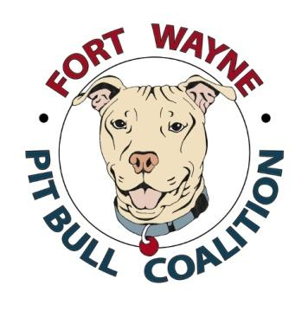
General Release & Waiver Agreement
I wish to participate in the Pits in the Park Event held on September 16, 2017 by the Fort Wayne Pit Bull Coalition. In consideration for permitting my participation in the Event, I agree to the terms of this Release & Waiver Agreement.
I acknowledge that by signing this Release & Waiver Agreement, I am releasing FWPBC and any other sponsoring or organizing parties, including, but not limited to, the Fort Wayne Parks Department, the City of Fort Wayne, the property owners, law enforcement agencies, or public entities associated with the Event, and their respective agents, directors, officials, and employees (“Released Parties”), from any and all liability for any acts, omissions or occurrences which may result, directly or indirectly, in injury to myself, my pet, or my personal property, as a result of my participation in or association with the Event, including travel to and from the Event, and I hereby agree to waive, release and forever discharge and hold harmless, on behalf of myself and my heirs, executors, administrators, legal representatives, assignees, and successors in interest, any and all claims for damages, rights or causes of actions which I may have, or which may hereafter accrue, against the Released Parties, including any claims arising from the Released Parties’ own negligence. I further agree to indemnify and hold harmless the Released Parties from any claims, rights or causes or actions which may accrue to any individual or entity participating in, involved with or present at the Event as a result, directly or indirectly, of my own acts or omissions, or the acts or omissions of my pet, during my participation in or association with the Event, including travel to and from the Event, and that I shall indemnify the Released Parties for any damages awarded or expenses incurred as a result of any such claims, rights or causes of action, including, but not limited to, attorney fees and court costs. I accept all liability for damage to property or persons caused by myself or my pet. I understand that this Release & Waiver Agreement is a contract, which has legal consequences and state that I have read all of its terms, fully understand them and am legally competent to execute this Release & Waiver Agreement. This Agreement may not be modified orally, and a waiver of any provision shall not be construed as a modification of any other provision herein or as consent to any subsequent waiver of modification.

Participant Name (please print): __________________________________________________
Company/Business Name: _________________________________________________________________
Address: _________________________________City ___________ State ____ Zip ________
Email: ____________________________ Phone ________________ Fax ________________
Participant Signature: ______________________________________ Date ________________
P.O. Box 13064, Fort Wayne, Indiana 46867

